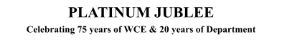

# Walchand College of Engineering, Sangli

***(Government Aided Autonomous Institute)***

Department of Information Technology

Computer Networks Lab

EVEN SEMESTER AY 2021-22

*Submitted by*

Name: Om Gharge

PRN: 2020BTEIT00041

Batch: S2

Course Code: 5IT272 Date: 25/05/2022

Contact Number: 9730369761

**Department of Information Technology**

2021-22

**Experiment Number:** 4

**Experiment Name:** Implement class A or B or C network with auto IP configuration using DHCP protocol on router

and observe IP configuration on host machine (PC).

# Contents:

**Problem Statement :** Implement class A or B or C network with auto IP configuration using DHCP protocol on router

and observe IP configuration on host machine (PC).

**Platform :** CISCO packet tracer

**Devices Required :** PC , Switch (2960-24TT), Router (1841) .

**Design :** 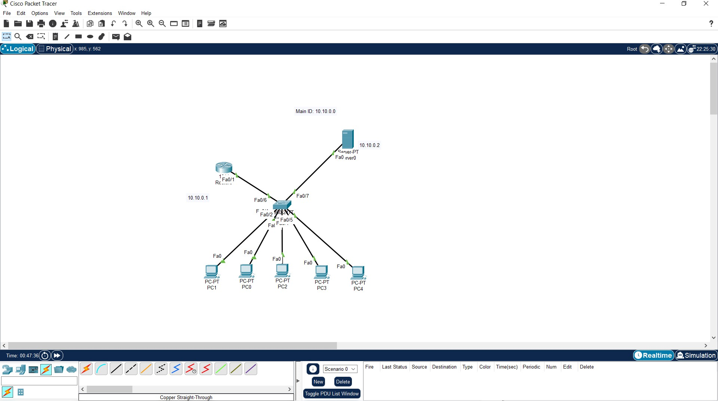

**Implementation :**

1. Create the topology as shown in the above image.
2. After creating the topology configure the network

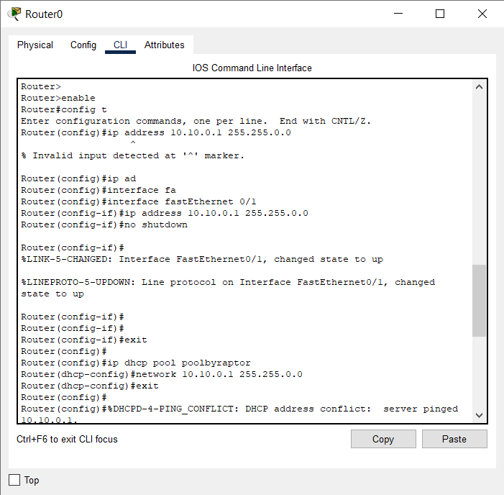

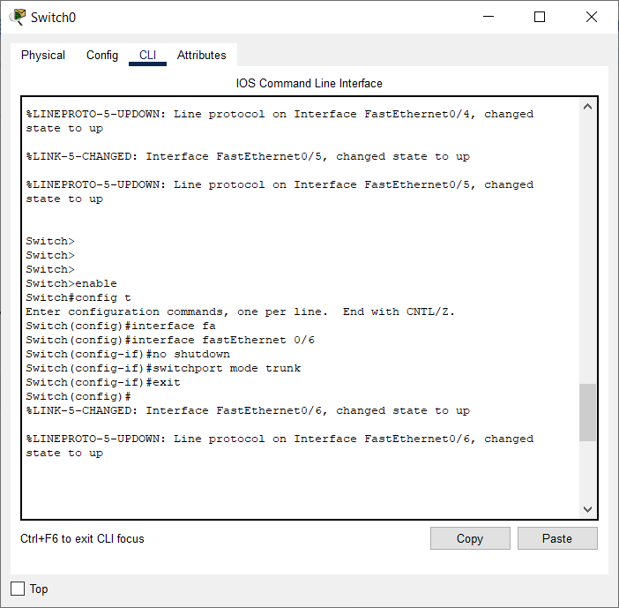

1. Configure the server and turn on the DHCP, add server pool to the server.

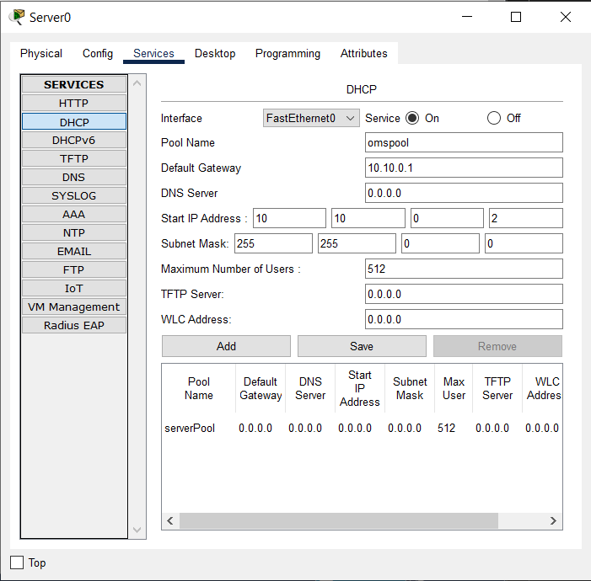

1. Turn on the DHCP in every system to give the ip to the computers.

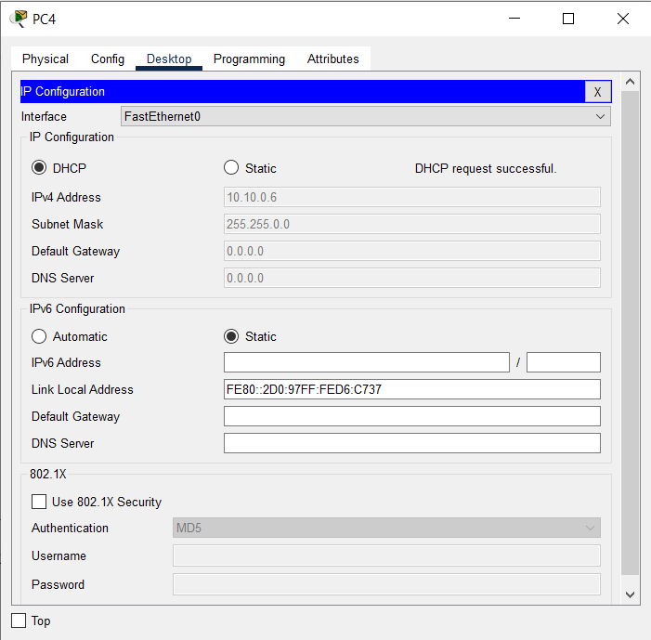

**Results:** DHCP protocols gives the IP to every end system in the network.

